Command Line Skills

5.1 Introduction
Most consumer operating systems are designed to shield the user from the ins and outs of the CLI. The Linux community is different in that it positively celebrates the CLI for its power, speed and ability to accomplish a vast array of tasks with a single command line instruction.

5.2 Shell
Once a user has entered a command the terminal then accepts what the user has typed and passes it to a shell. The shell is the command line interpreter that translates commands entered by a user into actions to be performed by the operating system. If output is produced by the command, then text is displayed in the terminal. If problems with the command are encountered, an error message is displayed.
The most commonly-used shell for Linux distributions is called the Bash shell. Bash provides many advanced features, such as command history and inline editing, which allows a user to easily re-execute previously executed commands or a variation of them via simple editing.

5.3 Commands
What is a command? The simplest answer is that a command is a software program that, when executed on the CLI, performs an action on the computer.
Many commands can be used by themselves with no further input. Some commands require additional input to run correctly. This additional input comes in two forms: options and arguments.
Options are used to modify the core behavior of a command while arguments are used to provide additional information (such as a filename or a username). Each option and argument is normally separated by a space, although options can often be combined.

5.3.1 History

When a command is executed in the terminal, it is stored in a history list. This is designed to make it easy to execute the same command, later eliminating the need to retype the entire command.

To view the history list of a terminal, use the history command:
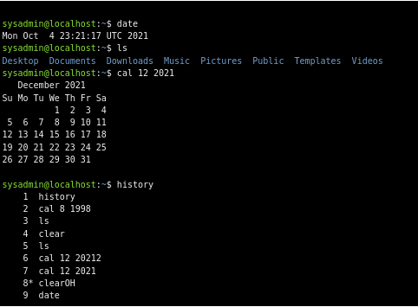

If the desired command is in the list that the history command generates, it can be executed by typing an exclamation point ! character and then the number next to the command.
If the history command is passed a number as an argument, it outputs that number of previous commands from the history list.
To execute the nth command from the bottom of the history list, type !-n and hit Enter.
To execute the most recent command type !! and hit Enter.
To execute the most recent iteration of a specific command, type ! followed by the name of the command and hit Enter. For example, to execute the most recent ls command:

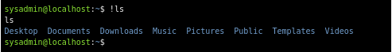

5.4 Variables
A variable is a feature that allows the user or the shell to store data. This data can be used to provide critical system information or to change the behavior of how the Bash shell (or other commands) work. Variables are given names and stored temporarily in memory. There are two types of variables used in the Bash shell: local and environment.

5.4.1 Local Variables
Local or shell variables exist only in the current shell, and cannot affect other commands or applications. When the user closes a terminal window or shell, all of the variables are lost. They are often associated with user-based tasks and are lowercase by convention.
The following example creates a local variable named variable1 and assigns it a value of Something:

The echo command is used to display output in the terminal. To display the value of the variable, use a dollar sign $ character followed by the variable name as an argument to the echo command:
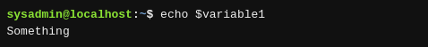

5.4.2 Environment Variables
Environment variables, also called global variables, are available system-wide, in all shells used by Bash when interpreting commands and performing tasks. The system automatically recreates environment variables when a new shell is opened. Examples include the PATH, HOME, and HISTSIZE variables. The HISTSIZE variable defines how many previous commands to store in the history list. The command in the example below displays the value of the HISTSIZE variable:
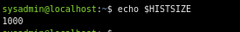

the env command outputs a list of the environment variables.
The export command is used to turn a local variable into an environment variable.
The export command can also be used to make a variable an environment variable upon its creation by using the assignment expression as the argument:
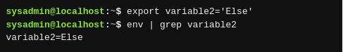

Exported variables can be removed using the unset command:

5.4.3 Path Variable
One of the most important Bash shell variables to understand is the PATH variable. It contains a list that defines which directories the shell looks in to find commands. If a valid command is entered and the shell returns a "command not found" error, it is because the Bash shell was unable to locate a command by that name in any of the directories included in the path. The following command displays the path of the current shell:
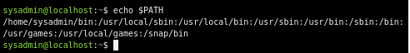

‌If custom software is installed on the system it may be necessary to modify the PATH to make it easier to execute these commands. For example, the following will add and verify the /usr/bin/custom directory to the PATH variable:
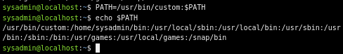

5.5 Command Types
One way to learn more about a command is to look at where it comes from. The type command can be used to determine information about command type.
type command
There are several different sources of commands within the shell of your CLI including internal commands, external commands, aliases, and functions.

5.5.1 Internal Commands
Also called built-in commands, internal commands are built into the shell itself. A good example is the cd (change directory) command as it is part of the Bash shell.

5.5.2 External Commands
External commands are stored in files that are searched by the shell. If a user types the ls command, then the shell searches through the directories that are listed in the PATH variable to try to find a file named ls that it can execute.
use the which command to display the full path to the command in question
External commands can also be executed by typing the complete path to the command. For example, to execute the ls command:

For external commands, the type command displays the location of the command:
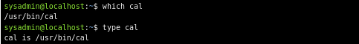

Using the -a option of the type command displays all locations that contain the command named:

5.5.3 Aliases
An alias can be used to map longer commands to shorter key sequences. When the shell sees an alias being executed, it substitutes the longer sequence before proceeding to interpret commands.
New aliases can be created using the following format, where name is the name to be given the alias and command is the command to be executed when the alias is run.
alias name=command
The type command can identify aliases to other commands:

5.5.4 Functions
Functions can also be built using existing commands to either create new commands, or to override commands built-in to the shell or commands stored in files. Aliases and functions are normally loaded from the initialization files when the shell first starts.

5.6 Quoting
Quotation marks are used throughout Linux administration and most computer programming languages to let the system know that the information contained within the quotation marks should either be ignored or treated in a way that is very different than it would normally be treated. There are three types of quotes that have special significance to the Bash shell: double quotes ", single quotes ', and back quotes `. Each set of quotes alerts the shell not to treat the text within the quotes in the normal way.

5.7 Control Statements
Control statements allow you to use multiple commands at once or run additional commands, depending on the success of a previous command. Typically these control statements are used within scripts, but they can also be used on the command line as well.

5.7.1 Semicolon
command1; command2; command3
The semicolon ; character can be used to run multiple commands, one after the other. Each command runs independently and consecutively; regardless of the result of the first command, the second command runs once the first has completed, then the third and so on.

5.7.2 Double Ampersand
command1 && command2
The double ampersand && acts as a logical "and"; if the first command is successful, then the second command will also run. If the first command fails, then the second command will not run.

5.7.3 Double Pipe
command1 || command2
With the double pipe, if the first command runs successfully, the second command is skipped; if the first command fails, then the second command is run. In other words, you are essentially telling the shell, "Either run this first command or the second one”.

